1. **灰盒模糊测试**：灰盒模糊测试介于黑盒和白盒模糊测试之间。在灰盒测试中，测试人员具有部分应用程序的内部结构和实现的信息，例如部分代码或设计规范。这些信息可以帮助测试人员更有针对性地设计测试用例，并在测试过程中引导模糊测试的输入生成。

**基于符号执行的白盒模糊测试**：需要大量的程序分析和约束求解

灰盒模糊测试介于两者之间，只使用轻量级的工具来收集一些程序结构。没有程序分析，灰盒模糊测试可以比白盒模糊测试更有效。有了更多关于内部结构的信息，它可以比黑盒模糊测试更有效。定向灰盒模糊测试增加了一些程序分析，控制流图和调用图。

通常模糊测试有一个种子集，种子就是确定会引发异常的测试用例，新的测试用例是通过种子变异无限循环，发送给执行器控制的被测对象，如果触发异常，这些测试用例就被记录下来，加入到种子集中，再次利用。通过不断的循环尝试，便可以越来越有效的发现漏洞。

**Test suite（测试套件）**：一组相关的测试，是许多测试用例的集合。通过测试套件，将服务于同一个测试目的或同一运行环境下的一系列测试用例有机的组合起来。测试套件是按照测试计划所定义的各个阶段的测试目标决定的，即先有测试计划，后面才有测试套件。

2、**Directed Greybox Fuzzing(DGF)**：定向灰盒模糊测试,这是一种漏洞检测技术，专注于到达用户定义的目标位置。

1. **vulnerability detection**：漏洞检测
2. 与非定向模糊器不同，定向模糊器将大部分时间预算用于到达特定的目标位置，而不会浪费资源在不相关的程序组件。
3. 定向模糊器的应用：补丁测试、崩溃重现、静态分析报告验证、信息流检测
4. **Symbolic execution：符号执行**，一种白盒模糊测试技术

传统上，定向模糊测试是基于符号执行进行的；大部分补丁测试工具基于定向符号执行

符号执行是一种程序分析技术，它可以通过分析程序来得到让特定代码区域执行的输入。当使用符号执行分析一个程序时，该程序会**使用符号值作为输入**，而非一般执行程序时使用的具体值。在达到目标代码时，分析器可以得到相应的路径约束，然后通过约束求解器来得到可以触发目标代码的具体值。

**定向符号执行（DSE）**：采用符号执行、程序分析和约束求解的重型机器，系统有效地探索可行路径的状态空间

缺点：效率不高，DSE花了相当多的时间进行重量级的程序分析和约束求解。

Katch是一个最先进的补丁测试工具，这是一种基于符号执行引擎Klee的定向白盒模糊器。大多数基于符号执行的白盒模糊器将错误检测直接集成到约束求解过程中。

1. DGF：重点是在程序中到达一组给定的目标位置，DGF将目标位置的可达性作为优化问题，而现有的定向(白盒)模糊方法将可达性作为迭代约束满足问题。
2. **HeartBleed漏洞（心脏出血漏洞）**：由于未能在memcpy()调用受害用户输入内容作为长度参数之前正确进行边界检查。攻击者可以追踪OpenSSL所分配的64KB缓存、将超出必要范围的字节信息复制到缓存当中再返回缓存内容，这样一来受害者的内存内容就会以每次64[KB](https://baike.baidu.com/item/KB/331?fromModule=lemma_inlink)的速度进行泄露。它危及通过所谓的安全协议(SSL/TLS)发送的数据的隐私和完整性。
3. （1）以一种无向的方式对所有OpenSSL进行模糊测试，而实际上只有最近的更改被认为是容易出错的，这将是对资源的浪费；（2）虽然基于定向符号执行的白盒模糊测试非常有效，但它也非常昂贵，费时。
4. 我们在流行且非常成功的**无向灰盒模糊器AFL**中实现了DGF，并将我们的定向灰盒模糊器称为AFLGo，AFL是基于覆盖率的灰盒模糊器（CGF）
5. **AFLGo**是一个非常有效的定向灰盒模糊器，在运行(run time)时几乎不需要程序分析，只需要在编译/检测（instrumentation time）时进行轻量级程序分析
6. AFLGo实现了基于SA的全局搜索，AFLGo实现了并行搜索，同时搜索所有目标
7. Call Graph(CG)：

表示一个计算机程序中子程序之间的调用关系。每个节点表示一个过程，每条边(f, g)表示过程f调用过程g

1. Control-flow graph(CFG):控制流图

是一个过程或程序的抽象表现，是用在[编译器](https://baike.baidu.com/item/%E7%BC%96%E8%AF%91%E5%99%A8/8853067?fromModule=lemma_inlink)中的一个[抽象数据结构](https://baike.baidu.com/item/%E6%8A%BD%E8%B1%A1%E6%95%B0%E6%8D%AE%E7%BB%93%E6%9E%84/22093090?fromModule=lemma_inlink)，由编译器在内部维护，代表了一个程序执行过程中会遍历到的所有路径。它用图的形式表示一个过程内所有基本块执行的可能流向, 也能反映一个过程的实时执行过程。

控制流图中每个在图形中的节点代表一个[基本块](https://baike.baidu.com/item/%E5%9F%BA%E6%9C%AC%E5%9D%97/6316788?fromModule=lemma_inlink)

1. 种子距离（seed distance）：
2. function-level target distance：函数到调用图中所有目标函数的距离
3. Function distance：调用图中任意两个函数之间的距离
4. Basic-block-level distance（BB-level distance）：从一个基本块到所有其他调用一个函数的基本块

基本块：其中只有一个入口和一个出口，入口就是其中的第—个语句，出口就是其中的最后一个语句。对一个基本块来说，执行时只从其入口进入，从其出口退出。

Notations:s—seed，Tb—target locations, m - basic block, n-function

1. 模拟退火算法（Simulated Annealing，SA）:

模拟退火(SA)[19]的灵感来自冶金中的退火过程，这是一种涉及加热和控制材料冷却以增加其晶体尺寸并减少其缺陷的技术。SA算法向全局最优解集渐近收敛,这个集合，在我们的例子中，是执行最大数量的目标位置的种子集合。SA是一种马尔可夫链蒙特卡罗方法(MCMC)，用于在可接受的时间预算内在非常大的、通常是离散的搜索空间中逼近全局最优解。温度是SA算法的一个参数，它调节较差解决方案的接受程度，并根据冷却计划（cooling schedule）降低。冷却计划控制收敛速度

Annealing-based power schedule (APS)：将更多的能量分配给离目标“更近”的种子，而不是“更远”的种子，这种能量差随着温度的降低而增加(即随着时间的推移)

1. AFLGo的评估：应用到补丁测试和崩溃重现上

2023.10.26

cur_location = <COMPILE_TIME_RANDOM>;

shared_mem[cur_location ^ prev_location]++;

prev_location = cur_location >> 1;

shared_mem数组是一个调用者 (caller) 传给被插桩的二进制程序的64kb的共享空间。其中的每一byte可以理解成对于特别的(branch_src, branch_dst)式的tuple的一次命中（hit）

1. 为什么要用随机数标识当前位置？

①简化连接复杂project的过程

②保持XOR输出均匀分布：shared_mem[cur_location ^ prev_location]++

如果标识数字是连续的，那么异或后发生碰撞的概率较大

1. shared_mem数组的大小为什么选择64KB

①让冲突尽可能减少，这样通常能处理2k~10k个分支点

②这个大小能使map分析时间到达毫秒级,适应L2缓存

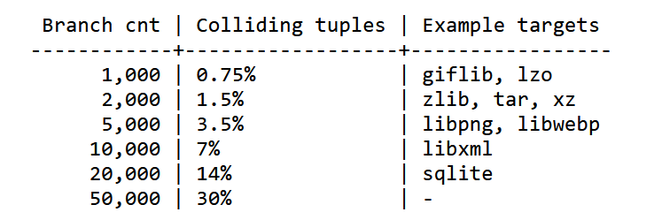

1. Forkserver

用于避免execve()的巨大开销

Fuzzer启动forkserver，由forkserver启动子进程和执行目标程序，fuzzer则通过管道与forkserver通信

1. Inst_ratio: Instrumentation probability (%)

初始值为100

1）针对使用ASAN编译的情况

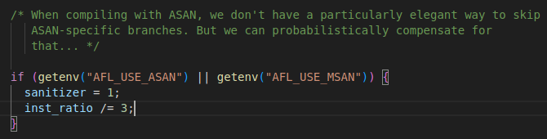

2）当代码过于复杂时可手动设置该参数

1. 计算元组被执行次数(hit count)

①

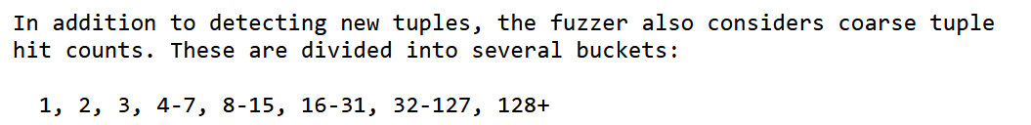

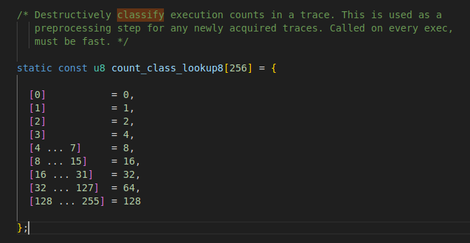

每次run_target执行classify_counts：

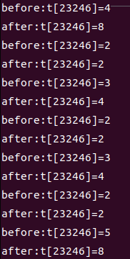



1. 桶内变化被忽略，跨桶变化被标记为”interesting change”

如：一个平常只执行一次的代码块被执行了两次；2）方便在has_new_bits中和virgin_bits进行与操作，判断是否出现新路径

②

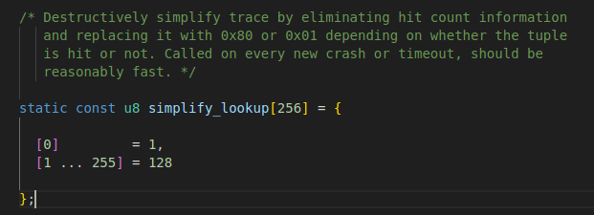

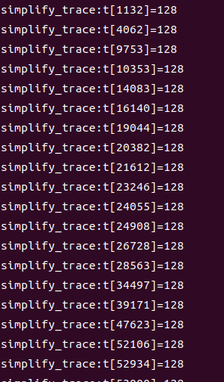

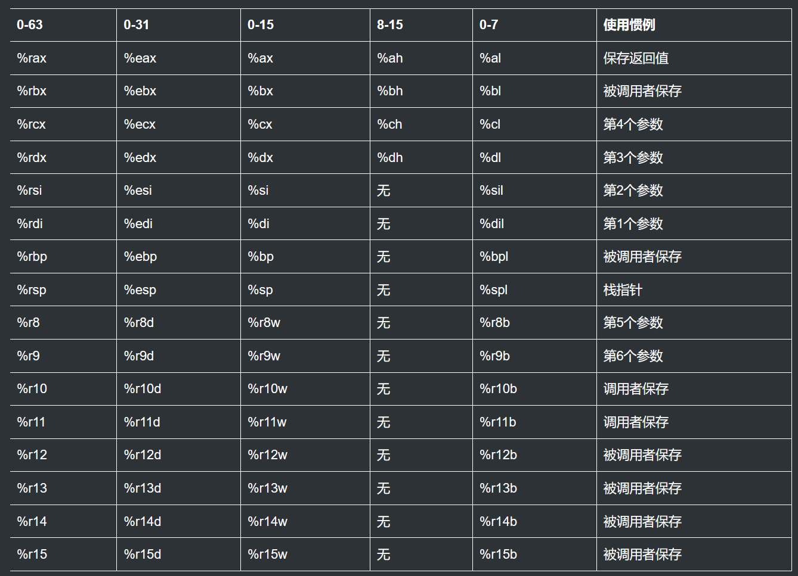

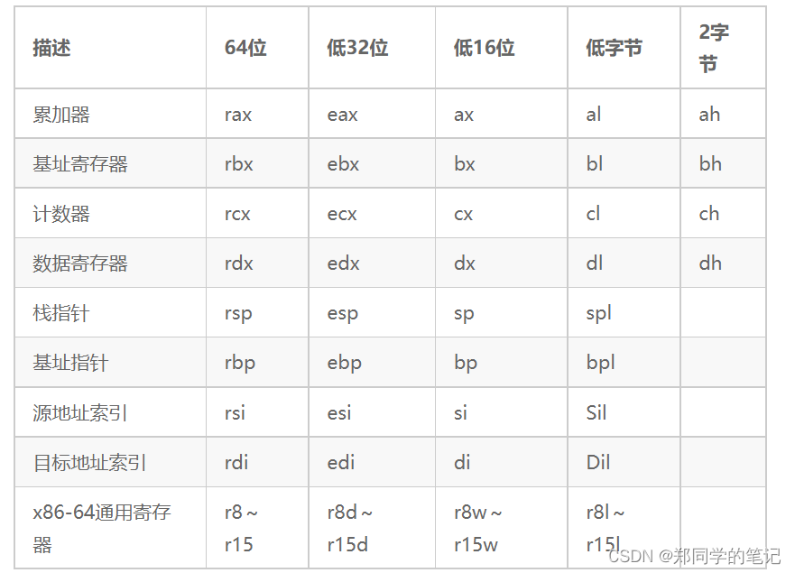

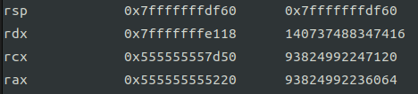



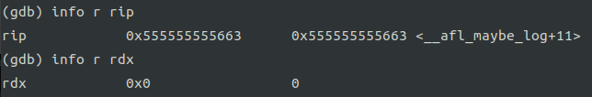



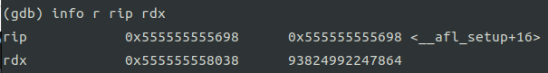

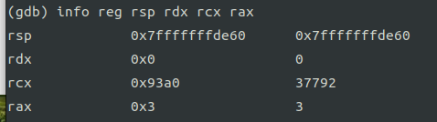

gdb afl-fuzz -ex "set args -t 5000 -i fuzz_in/ -o fuzz_out/ ./test_afl"

b init_forkserver

set follow-fork-mode child

set follow-exec-mode new（Cannot access memory at address 0x401adf错误），应该换成 catch exec

r

n

add-symbol-file /home/jiafeimao/test_afl

b __writetofile

可以通过系统中断的方式将数字写入文件，只不过写入的是16进制数据

是否可以将寄存器中的数据写入文件中呢？

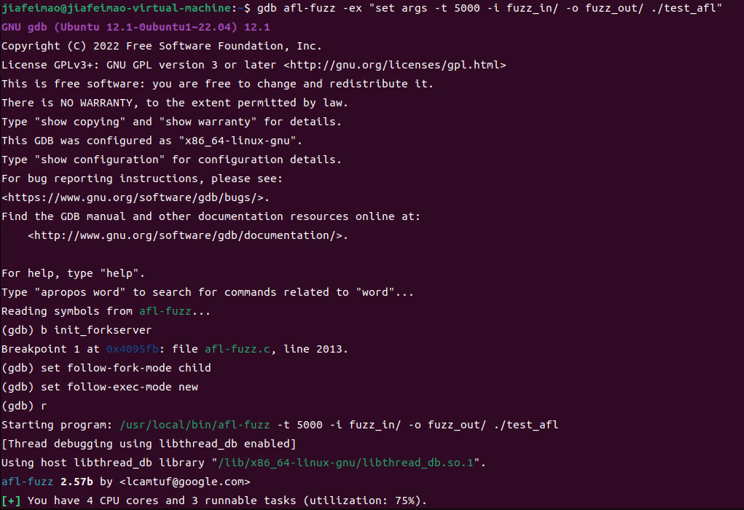

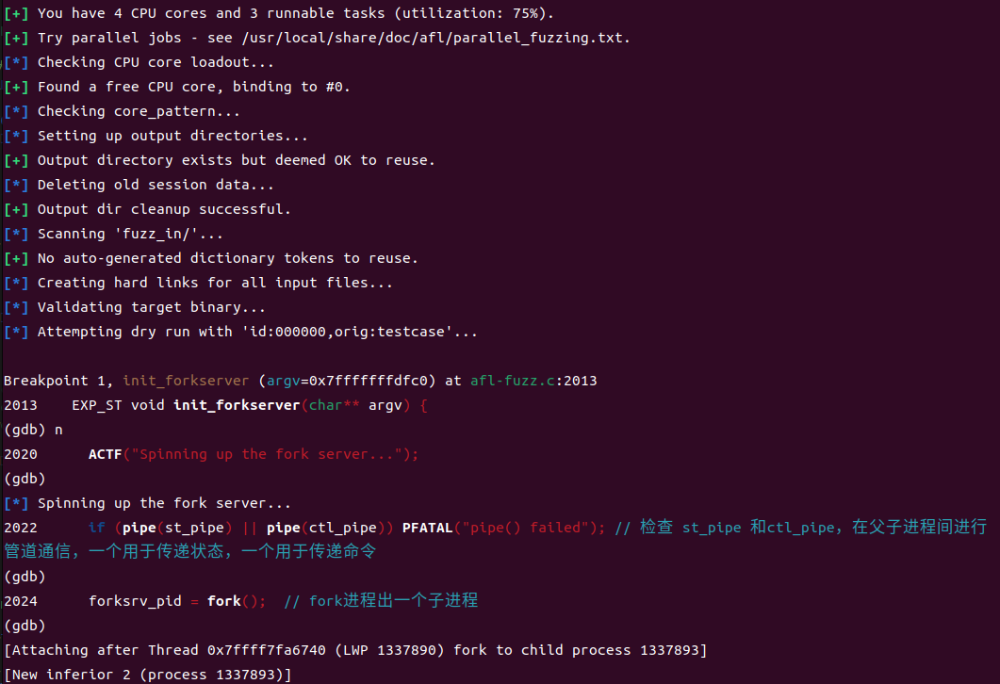

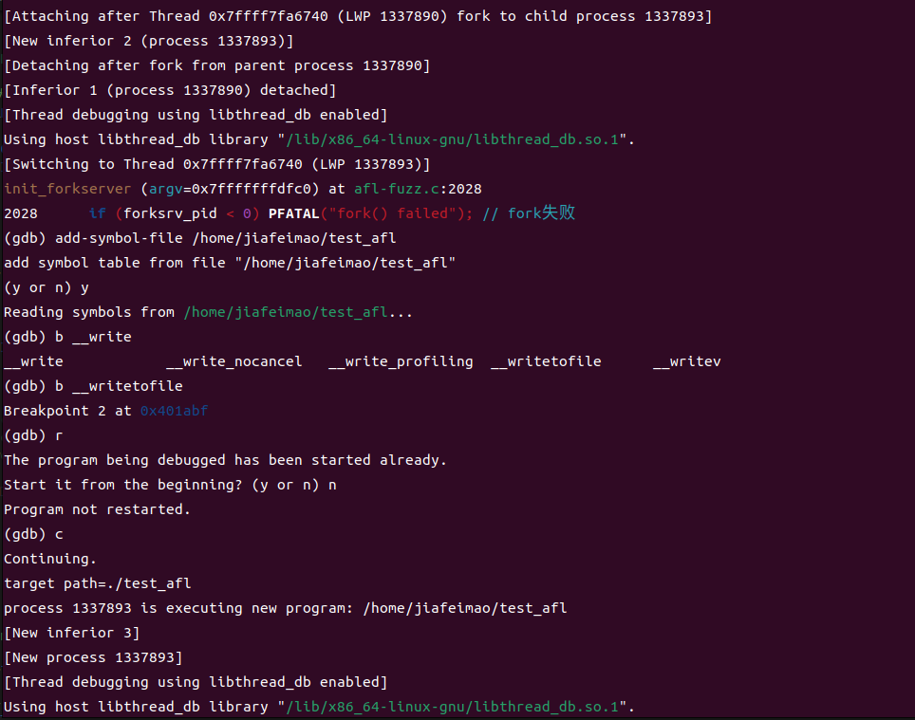

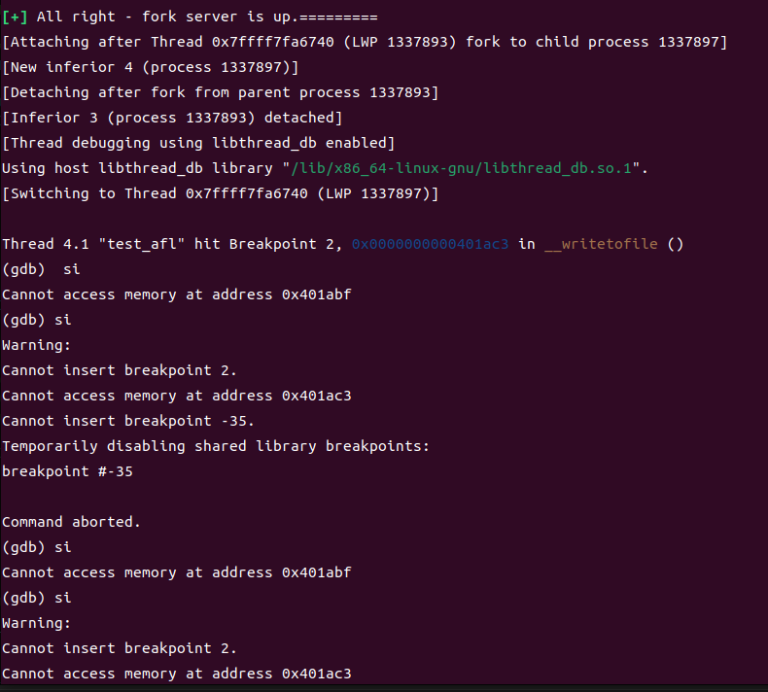

Run time : 1min

testfile1 880.4KB

testcase_file.txt 1.9MB

23.12.8

校验testfile1和testcase_file.txt是否匹配

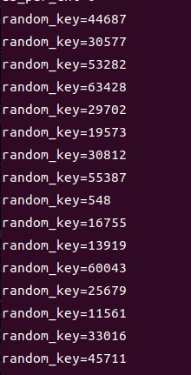

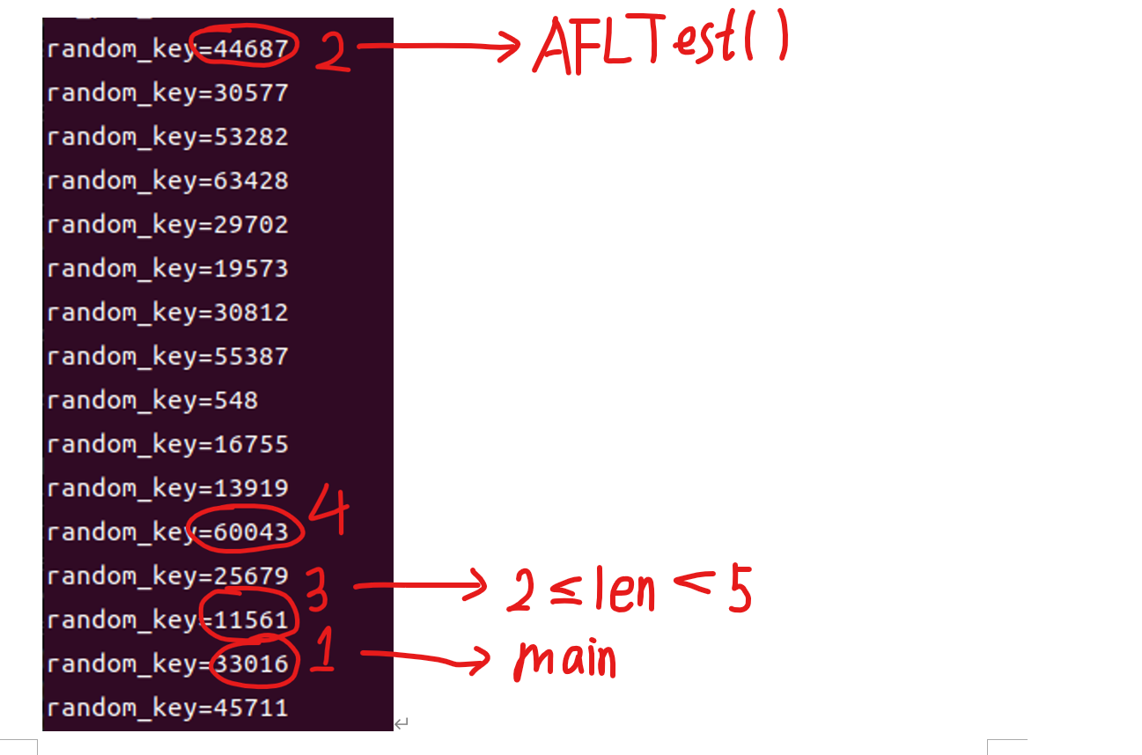

23.12.14

对记录testcase的testcase_file.txt的处理：

1）如何分隔开不同的testcase？将每个testcase前面加上”mem=”

2）如何避免testcase中含有mem=？类似转义

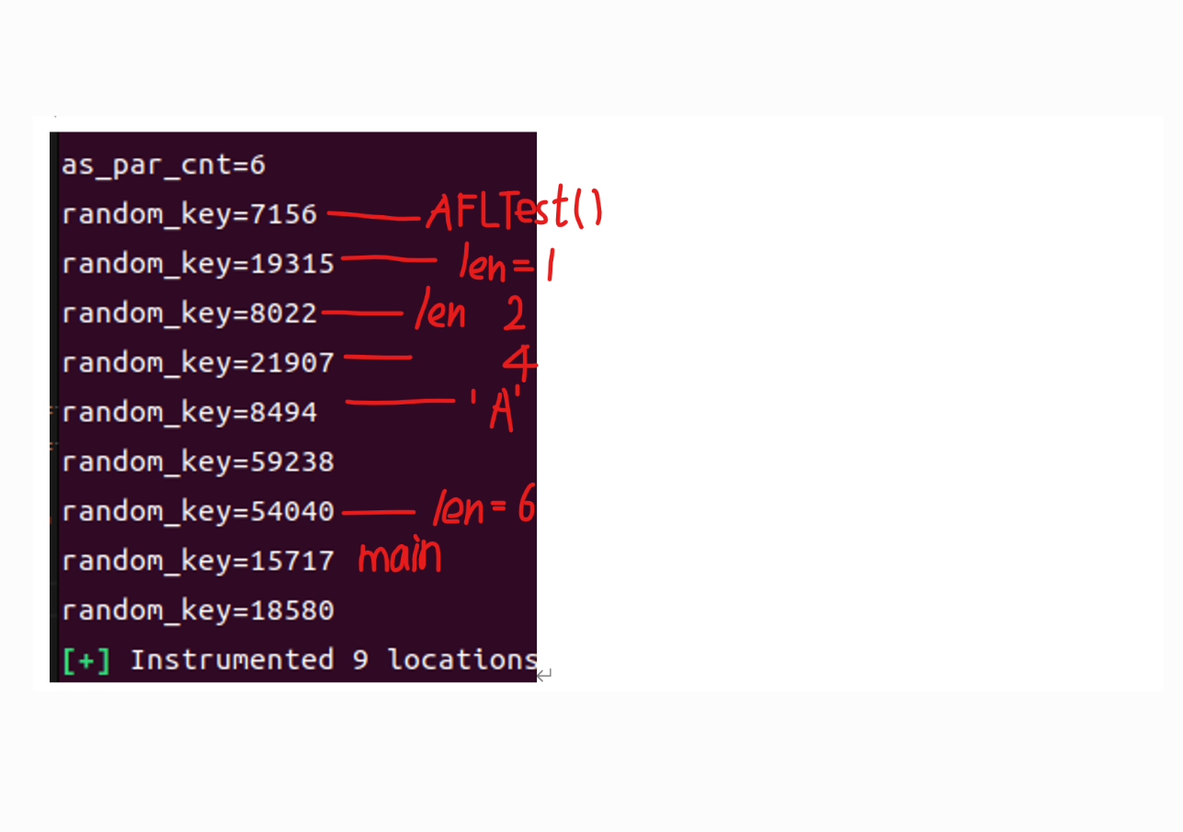

23.12.18

Ida pro

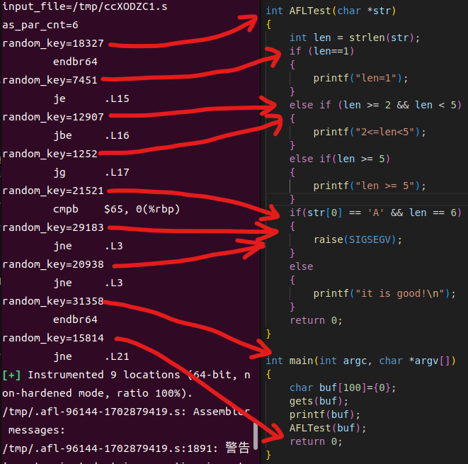

1. 路径有些不太对？同样的测试用例路径不一样（已解决，看24.1.5记录）

2、所有run_target都存了，不只是fuzz的

3、转义怎么转？（已完成）

无需转义，可以把每个testcase的字节数记录下来

23.12.19

1、随机数右移后再左移恢复会差一位是什么原因：如果最后一位是1的话，右移在左移补的是0，所以转换成十进制会相差1

2、为什么输出的测试用例一开始会重复好几次？

Calibrate_case函数在校验时是在一个循环中的，循环次数为stage_max

stage_max = fast_cal ? 3 : CAL_CYCLES; CAL_CYCLES=8

哪些函数调用calibrate_case : perform_dry_run() （只在main函数中调用一次）、 save_if_interesting() （common_fuzz_stuff）、fuzz_one()(only if failed earlier on)

为什么要设置stage_max？

在发现新的路径时，用以评估这个新发现的testcase的行为是否是可变（这里的可变是指多次执行这个case，发现的路径不同）

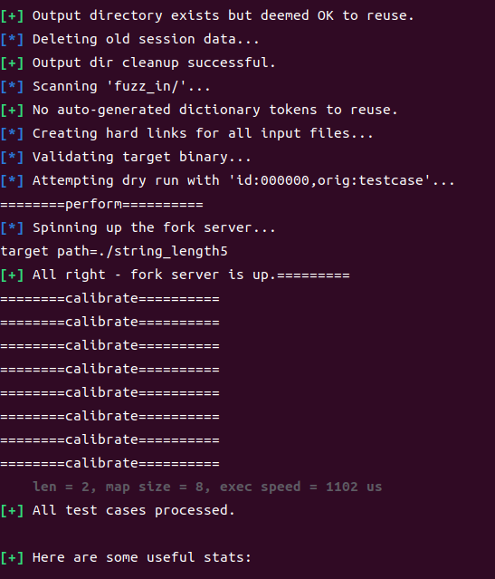

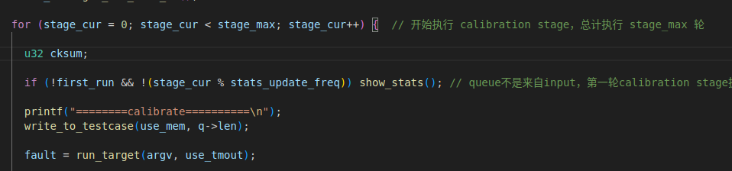

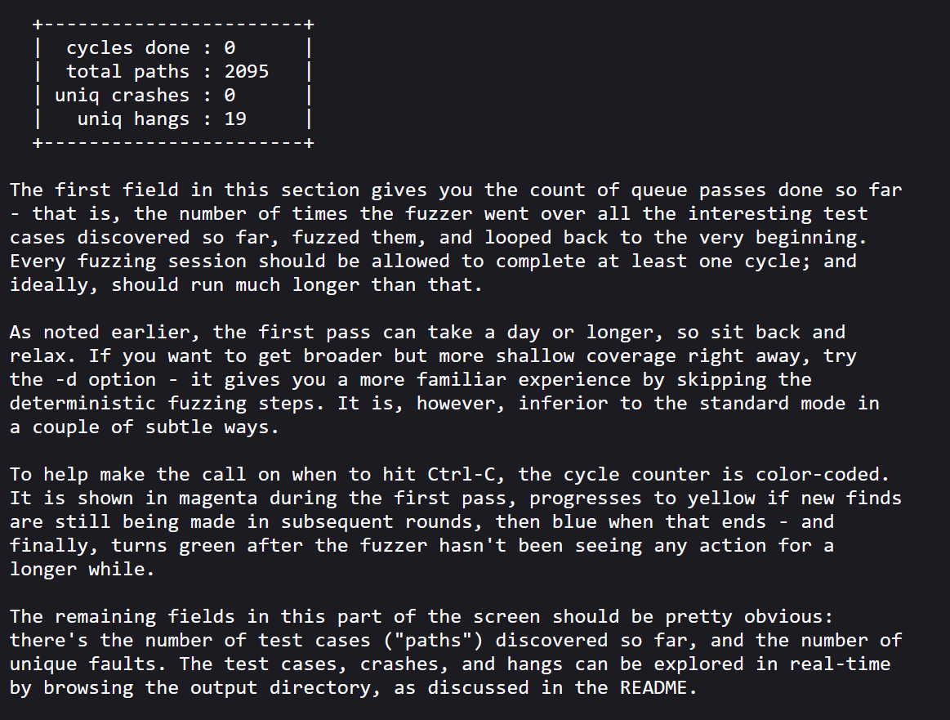

23.12.20

1、确定bug是否可复现

确认可复现

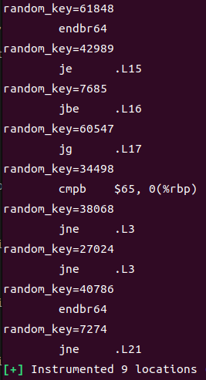F198（刚进入AFLTest()函数）

A7ED（cmp $0x1,%eax 不满足该条件时输出该桩id）

1E05（cmp $0x2,%eax）

EC83（cmp $0x4,%ebx len >= 5 不满足该条件时输出该桩id）

86C2

94B4（cmpb $0x41,0x0(%rbp) 满足该条件时输出该桩id

jne 401538 <AFLTest+0x118> str[0] == 'A'）

6990（cmp $0x6,%ebx 满足该条件时输出该桩id

jne 401538 <AFLTest+0x118>）未执行

9F52 （刚开始进入main函数）

1C6A （调用完AFLTest()函数并退出）未执行

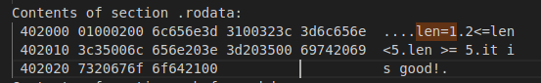

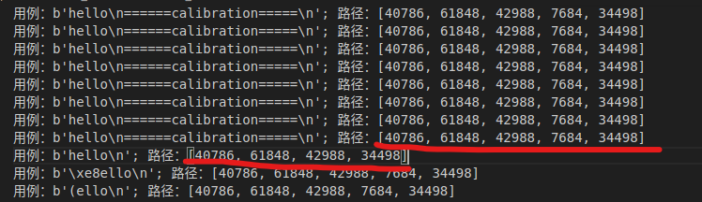

2、确定自己的代码是否有问题

3、通过反编译排查问题

新发现：如果该if条件被满足，那么程序就会跳转执行，而由于桩插在跳转语句下面的位置，跳转完了不会返回，因此该桩并不会被hit

23.12.21

分析afl-as.c中add_instrumentation()：

1. 何时插桩？
   1. .text\n ; section\t.text ; section\t__TEXT,__text ; section __TEXT,__text 桩在先
   2. \t line[1] == 'j' && line[2] != 'm' && R(100) < inst_ratio 桩在后
   3. .L<whatever> Isdigit(line[2]) || (clang_mode && .LBB) && R(100) < inst_ratio桩在先

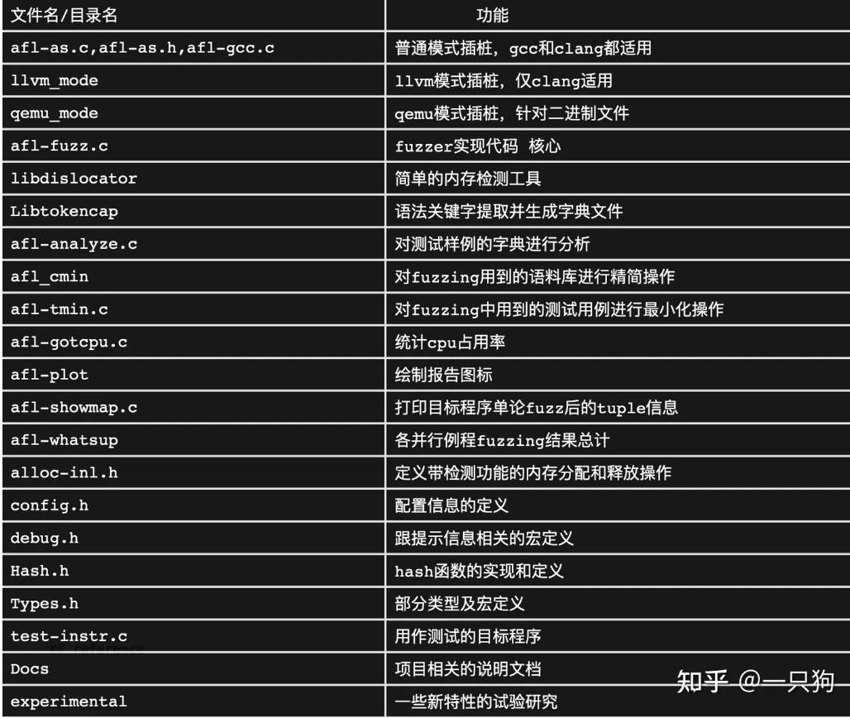

1. 为什么这条不一样的路径没有触发calibration？

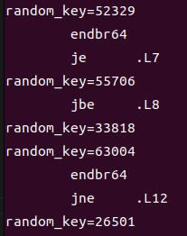23.12.22

aflTest() 进入该函数被hit

当len==1分支不满足时该桩被hit

该桩被hit表示第2个条件也不满足，执行最后一个条件

Main

return

656d 3d6d 6a6b 3173 3332

6d0a 6d65 6b3d 736a 3231 0a33

656d 3d6d 6a6b 3173 3332

6d0a 6d65 6b3d 736a 3231 0a33

656d 3d6d 6a6b 3173 3332

6d0a 6d65 6b3d 736a 3231 0a33

656d 3d6d 6a6b 3173 3332

6d0a 6d65 6b3d 736a 3231 0a33

656d 3d6d 6a6b 3173 3332

6d0a 6d65 6b3d 736a 3231 0a33

A：为什么读testcase总要加个换行符？明明没有这个

S：写文件时自动加换行符，使用echo写入文件时加上-n，就没有换行符了

Testfile1和testcase_file每次记录后要自动清空（已解决）

24.1.2

736b 646a 6577

736b 646a 6577

736b 646a 6577

736b 646a 6577

736b 646a 6577

736b 646a 6577

736b 646a 6577

736b 646a 6577

736b 646a 6577

736b 646a 6577

73eb 646a 6577

732b 646a 6577

24.1.5

Q：路径有些不太对？同样的测试用例路径不一样

A：在将测试用例写入文件时，有一个用例存错了，执行该用例的函数是trim_case()，该函数在fuzz_one()函数最开始调用（需满足的条件是 !dumb_mode && !queue_cur->trim_done）。

这个函数的主要功能是对给定的测试用例进行削减，以减少测试用例的大小，从而提高测试效率。具体来说，它会按照一定的步长对测试用例进行削减，并在每次削减后运行目标程序，以检查是否发现了崩溃或其他异常行为。如果发现异常行为，则说明该削减过程导致了程序行为的变化，因此该削减就被撤销。如果没有发现异常行为，则说明该削减没有影响程序行为，因此该削减可以被保留。

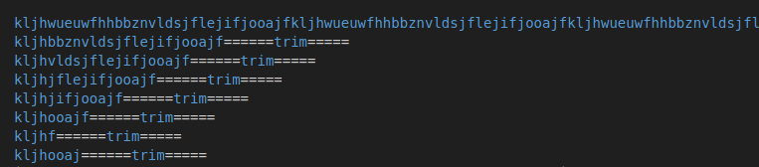

不可复现的bug：

输入文件：

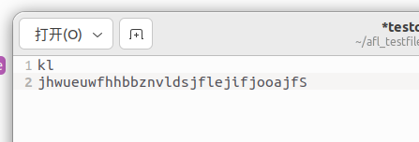

结果文件res_file56.txt

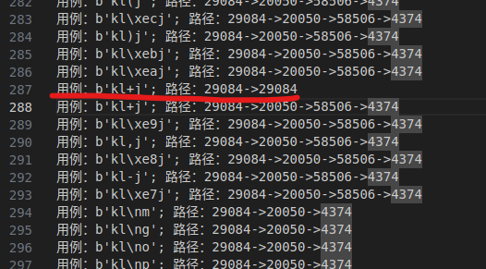

不可复现bug

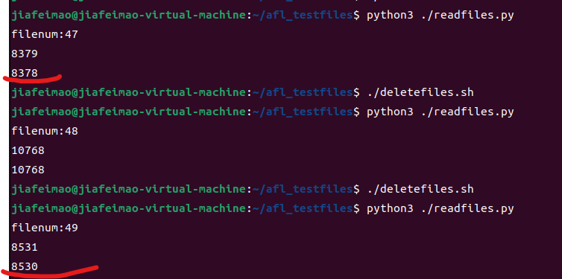  
24.3.6

搞清楚setrlimit能不能用

Fuzzer要求短时间内运行多个目标程序，喂入变异后的测试用例，监测目标进程状态，如果频繁调用execve()系统调用，会消耗大量的系统资源

为了提高效率，afl-fuzz在执行一个目标程序后，启动fork-server，由它来负责fork进程，fuzzer本身不负责fork进程的任务，fuzzer（父进程）通过管道，与forkserver（子进程）通信，这样做的好处是不会频繁调用execve，也不会进行载入目标文件和库、解析符号地址等重复性工作。父进程继续执行afl-fuzz的主程序逻辑，子进程中执行forkserver函数.

如果我们自己想写个fuzz的程序，最简单的思路莫过于将输入用例做随机变换之后尝试将其作为输入给程序查看执行情况，即调用execv这样的函数，但是这样的代价是很高的，因为在调用exec这个函数之后将产生一个的新程序来代替原进程，当前进程的数据段、代码段和堆栈段都会被改变，且新的进程的PID同原进程相同，我们无法通过PID来标识不同的测试用例，这种方式是很低效的。因此原作者用一种新的结构进行开发，即forserver架构。也就是每次要进行测试的时候就fork出一个子进程进行测试，子进程复制父进程的数据段等，且拥有自己的PID，这就是进程的写时复制。这样的好处就是我们省去了重新装载程序的时间。

24.3.14

1、执行窗口从什么地方开始？

涉及到记录桩id的函数只有run_target()，但调用run_target()的函数有好多

打算使用计时器来控制执行窗口的时间，问题是计时器从哪开始计时

出事了！丢失了一部分代码，救命啊

好了 现在应该重新修改好代码！

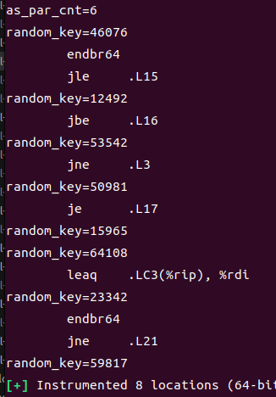

24.3.17

1、执行窗口从什么地方开始？

涉及到记录桩id的函数只有run_target()，但调用run_target()的函数有好多

打算使用计时器来控制执行窗口的时间，问题是计时器从哪开始计时

使用ps -ef命令查看进程，发现afl-fuzz是目标程序的父进程，表明，fuzzer是forkserver的父进程



使用ps axj命令查看守护进程，发现目标程序（forkserver）是守护进程（-1），PID和PGID相等





想法：直接在afl-fuzz.c中的forkserver那里加入一个定时器

24.3.18

需要实现的功能：每隔1s，fork_server挂起，主程序处理这段时间的输入、路径，处理完后清空这两个文件，唤醒fork_server

sleep()不占用cpu时间

setrlimit限制cpu时是以单核为单位的

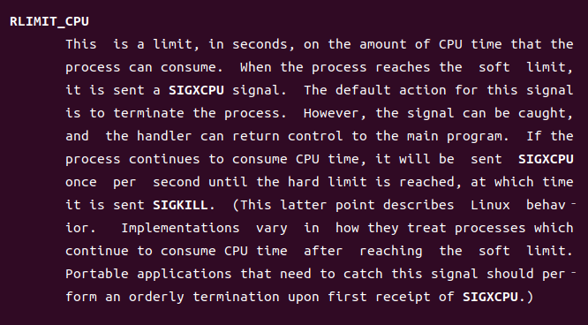

24.3.19

还是打算用setrlimit实现

到达软限制后，接收到SIGXCPU信号，默认动作是终止进程，不过这个信号可以被捕捉，然后可以将控制权转回主程序。如果该进程持续消耗cpu时间，每隔1s会持续发送SIGXCPU信号，直到硬限制到达。

目前的做法：

捕获到SIGXCPU信号后，fork出一个子进程来进行事务处理（处理输入、路径等），此期间父进程（forkserver）处于阻塞状态，子进程处理完后退出，父进程恢复执行。

现在的问题：

每隔1s发送信号怎么搞，因为执行窗口的时间是常量

24.3.24

纠正：在捕获到SIGXCPU信号后执行handle函数是和主程序异步执行的，也就是说此时主程序是处于阻塞状态，那么并不需要fork子进程来处理

换alarm来处理！

24.3.25

Alarm函数：定时发送SIGALRM给当前进程，默认动作为终止进程，只会执行一次

24.4.25

任务：每次复制文件前，在原路径文件后插入一个字符串，看看最终这个字符串在哪个位置

[0, 58328, 58328, 24776, 24776, 54904, 54904, 52844, 52844, 5554, 5554, 21704, 0, 58328, 58328, 24776, 24776, 54904, 54904, 52844, 52844, 5554, 5554, 21704, 0, 58328, 58328, 24776, 24776, 54904, 54904, 52844, 52844, 5554, 5554, 21704, 0, 58328, 58328, 24776, 24776, 54904, 54904, 52844, 52844, 5554, 5554, 21704, 0, 58328, 58328, 24776, 24776, 54904, 54904, 52844, 52844, 5554, 5554, 21704, 0, 58328, 58328, 24776, 24776, 54904, 54904, 52844, 52844, 5554, 5554, 21704, 0, 58328, 58328, 24776, 24776, 54904, 54904, 52844, 52844, 5554, 5554, 21704, 0, 58328, 58328, 24776, 24776, 54904, 54904, 52844, 52844, 5554, 5554, 21704, 'bj', 'bj', 0, 58328, 58328, 24776, 24776, 54904, 54904, 52844, 52844, 5554, 5554, 21704, 0, 58328, 58328, 24776, 24776, 54904, 54904, 52844, 52844, 5554, 5554, 21704, 'bj', 0, 58328, 58328, 24776, 24776, 54904, 54904, 5554, 5554, 21704, 'bj', 0, 58328, 58328, 24776, 24776, 54904, 54904, 52844, 52844, 5554, 5554, 21704, 'bj', 0, 58328, 58328, 24776, 24776, 54904, 54904, 52844, 52844, 5554, 5554, 21704, 'bj', 0, 58328, 58328, 24776, 24776, 54904, 54904, 52844, 52844, 5554, 5554, 21704, 0, 58328, 58328, 24776, 24776, 54904, 54904, 52844, 52844, 5554, 5554, 21704, 'bj', 0, 58328, 58328, 24776, 24776, 54904, 54904, 52844, 52844, 5554, 5554, 21704, 0, 58328, 58328, 24776, 24776, 54904, 54904, 52844, 52844, 5554, 5554, 21704, 0, 58328, 58328, 24776, 24776, 54904, 54904, 52844, 52844, 5554, 5554, 21704, 0, 58328, 58328, 24776, 24776, 54904, 54904, 52844, 52844, 5554, 5554, 21704, 0, 58328, 58328, 24776, 24776, 54904, 54904, 52844, 52844, 5554, 5554, 21704, 0, 58328, 'bj', 0, 58328, 58328, 24776, 24776, 54904, 54904, 52844, 52844, 5554, 5554, 21704, 0, 58328, 58328, 24776, 24776, 54904, 54904, 52844, 52844, 5554, 5554, 21704, 0, 58328, 58328, 24776, 24776, 54904, 54904, 52844, 52844, 5554, 5554, 21704, 0, 58328, 58328, 24776, 24776, 54904, 54904, 52844, 52844, 5554, 5554, 21704, 0, 58328, 58328, 24776, 24776, 54904, 54904, 52844, 52844, 5554, 5554, 21704, 0, 58328, 58328, 24776, 24776, 54904, 54904, 52844, 52844, 5554, 5554, 21704, 0, 58328, 58328, 24776, 24776, 54904, 54904, 52844, 52844, 5554, 5554, 21704, 'bj', 0, 58328, 58328, 24776, 24776, 54904, 54904, 52844, 52844, 5554, 5554, 21704, 0, 58328, 58328, 24776, 24776, 54904, 54904, 52844, 52844, 5554, 5554, 21704, 'bj', 0, 58328, 58328, 24776, 24776, 54904, 54904, 52844, 52844, 5554, 5554, 21704, 'bj', 0, 58328, 58328, 24776, 24776, 54904, 54904, 52844, 52844, 5554, 5554, 21704, 0, 58328, 58328, 24776, 24776, 54904, 54904, 52844, 52844, 5554, 5554, 21704, 'bj', 0, 58328, 58328, 24776, 24776, 54904, 54904, 52844, 52844, 5554, 'bj', 5554, 21704, 0, 58328, 58328, 24776, 24776, 54904, 54904, 52844, 52844, 5554, 5554, 21704, 'bj', 0, 58328, 58328, 24776, 24776, 54904, 54904, 52844, 52844, 5554, 5554, 21704, 'bj', 0, 58328, 58328, 24776, 24776, 54904, 54904, 52844, 52844, 5554, 5554, 21704, 0, 58328, 58328, 24776, 24776, 54904, 54904, 52844, 52844, 5554, 5554, 21704, 0, 58328, 58328, 24776, 24776, 54904, 54904, 52844, 52844, 5554, 5554, 21704, 0, 58328, 58328, 24776, 24776, 54904, 54904, 52844, 52844, 5554, 5554, 21704, 0, 58328, 58328, 24776, 24776, 54904, 54904, 52844, 52844, 5554, 5554, 21704, 0, 58328, 58328, 24776, 24776, 54904, 54904, 52844, 52844, 5554, 5554, 21704, 0, 58328, 58328, 24776, 24776, 54904, 54904, 52844, 52844, 5554, 5554, 21704, 0, 58328, 58328, 24776, 24776, 54904, 54904, 52844, 52844, 5554, 5554, 21704, 0, 58328, 58328, 24776, 24776, 54904, 54904, 52844, 52844, 5554, 5554, 21704, 0, 58328, 58328, 24776, 24776, 54904, 54904, 52844, 52844, 5554, 5554, 21704, 0, 58328, 58328, 24776, 24776, 54904, 54904, 52844, 52844, 5554, 5554, 21704, 0, 58328, 58328, 24776, 24776, 54904, 54904, 52844, 52844, 5554, 5554, 21704, 0, 58328, 58328, 24776, 24776, 54904, 54904, 52844, 52844, 5554, 5554, 21704, 'bj', 0, 58328, 58328, 24776, 24776, 54904, 54904, 52844, 52844, 5554, 5554, 21704, 'bj', 0, 58328, 58328, 24776, 24776, 54904, 54904, 52844, 52844, 5554, 5554, 21704, 0, 58328, 58328, 24776, 24776, 54904, 54904, 52844, 52844, 5554, 5554, 21704, 'bj', 'bj', 0, 58328, 58328, 24776, 24776, 54904, 54904, 52844, 52844, 5554, 5554, 21704, 'bj', 0, 58328, 58328, 24776, 24776, 54904, 54904, 52844, 52844, 5554, 5554, 21704, 'bj', 0, 58328, 58328, 24776, 24776, 54904, 54904, 52844, 52844, 5554, 5554, 21704, 'bj', 0, 58328, 58328, 24776, 24776, 54904, 54904, 52844, 52844, 5554, 5554, 21704, 'bj', 'bj', 0, 58328, 58328, 24776, 24776, 54904, 54904, 52844, 52844, 5554, 5554, 21704, 'bj', 'bj', 0, 58328, 58328, 24776, 24776, 54904, 54904, 52844, 52844, 5554, 5554, 21704, 'bj', 0, 58328, 58328, 24776, 24776, 54904, 54904, 52844, 52844, 5554, 5554, 21704, 'bj', 0, 58328, 58328, 24776, 24776, 54904, 54904, 52844, 52844, 5554, 5554, 21704, 0, 58328, 58328, 24776, 24776, 54904, 54904, 52844, 52844, 5554, 5554, 21704, 0, 58328, 58328, 24776, 24776, 54904, 54904, 52844, 52844, 5554, 5554, 21704, 'bj', 0, 58328, 58328, 24776, 24776, 54904, 54904, 52844, 52844, 5554, 5554, 21704, 0, 58328, 58328, 24776, 24776, 54904, 54904, 52844, 52844, 5554, 5554, 21704, 0, 58328, 58328, 24776, 24776, 54904, 54904, 52844, 52844, 5554, 5554, 21704, 'bj', 0, 58328, 58328, 24776, 24776, 54904, 54904, 52844, 52844, 5554, 5554, 21704, 0, 58328, 58328, 24776, 24776, 54904, 54904, 52844, 52844, 5554, 5554, 21704, 'bj', 0, 58328, 58328, 24776, 24776, 54904, 54904, 52844, 52844, 5554, 5554, 21704, 0, 58328, 58328, 24776, 24776, 54904, 54904, 52844, 52844, 5554, 5554, 21704, 0, 58328, 58328, 24776, 24776, 54904, 54904, 52844, 52844, 5554, 5554, 21704, 'bj', 0, 58328, 58328, 24776, 24776, 54904, 54904, 52844, 52844, 5554, 5554, 21704, 'bj', 0, 58328, 58328, 24776, 24776, 54904, 54904, 52844, 52844, 5554, 5554, 21704, 'bj', 0, 58328, 58328, 24776, 24776, 54904, 54904, 52844, 52844, 5554, 5554, 21704, 'bj', 0, 58328, 58328, 24776, 24776, 54904, 54904, 52844, 52844, 5554, 5554, 21704, 'bj', 'bj', 'bj', 0, 58328, 58328, 24776, 24776, 54904, 54904, 52844, 52844, 5554, 5554, 21704, 'bj', 'bj', 0, 58328, 58328, 24776, 24776, 54904, 54904, 52844, 52844, 5554, 5554, 21704, 0, 58328, 58328, 24776, 24776, 54904, 54904, 52844, 52844, 5554, 5554, 21704, 0, 58328, 58328, 24776, 24776, 54904, 54904, 52844, 52844, 5554, 5554, 21704, 'bj', 0, 58328, 58328, 24776, 24776, 54904, 54904, 52844, 52844, 5554, 5554, 21704, 0, 58328, 58328, 24776, 24776, 54904, 54904, 52844, 52844, 5554, 5554, 21704, 0, 58328, 58328, 24776, 24776, 54904, 54904, 52844, 52844, 5554, 5554, 21704, 0, 58328, 58328, 24776, 24776, 54904, 54904, 52844, 52844, 5554, 5554, 21704, 0, 58328, 58328, 24776, 24776, 54904, 54904, 52844, 52844, 5554, 5554, 21704, 0, 58328, 58328, 24776, 24776, 54904, 54904, 52844, 52844, 5554, 5554, 21704, 'bj', 0, 58328, 58328, 24776, 24776, 54904, 54904, 52844, 52844, 5554, 5554, 21704, 'bj', 0, 58328, 58328, 24776, 24776, 54904, 54904, 52844, 52844, 5554, 5554, 21704, 0, 58328, 58328, 24776, 24776, 54904, 54904, 52844, 52844, 5554, 5554, 21704, 0, 58328, 58328, 24776, 24776, 54904, 54904, 52844, 52844, 5554, 5554, 21704, 0, 58328, 58328, 24776, 24776, 54904, 54904, 52844, 52844, 5554, 5554, 21704, 0, 58328, 58328, 24776, 24776, 54904, 54904, 52844, 52844, 5554, 5554, 21704, 0, 58328, 58328, 24776, 24776, 54904, 54904, 52844, 52844, 5554, 5554, 21704, 0, 58328, 58328, 24776, 24776, 54904, 54904, 52844, 52844, 5554, 5554, 21704, 0, 58328, 58328, 24776, 24776, 54904, 54904, 52844, 52844, 5554, 5554, 21704, 'bj', 0, 58328, 58328, 24776, 24776, 54904, 54904, 52844, 52844, 5554, 5554, 21704, 'bj', 0, 58328, 58328, 24776, 24776, 54904, 54904, 52844, 52844, 5554, 5554, 21704, 'bj', 0, 58328, 58328, 24776, 24776, 54904, 54904, 52844, 52844, 5554, 5554, 21704, 0, 58328, 58328, 24776, 24776, 54904, 54904, 52844, 52844, 5554, 5554, 21704, 'bj', 0, 58328, 58328, 24776, 24776, 54904, 54904, 52844, 52844, 5554, 5554, 21704, 'bj', 0, 58328, 58328, 24776, 24776, 54904, 54904, 52844, 52844, 5554, 5554, 21704, 0, 58328, 58328, 24776, 24776, 54904, 54904, 52844, 52844, 5554, 5554, 21704, 'bj', 'bj', 0, 'bj', 'bj', 58328, 58328, 24776, 24776, 54904, 54904, 52844, 52844, 5554, 5554, 21704, 0, 58328, 58328, 24776, 24776, 54904, 54904, 52844, 52844, 5554, 5554, 21704, 'bj', 0, 58328, 58328, 24776, 24776, 54904, 54904, 52844, 52844, 5554, 5554, 21704, 'bj', 0, 58328, 58328, 24776, 24776, 54904, 54904, 52844, 52844, 5554, 5554, 21704, 0, 58328, 58328, 24776, 24776, 54904, 54904, 52844, 52844, 5554, 5554, 21704, 0, 58328, 58328, 24776, 24776, 54904, 54904, 52844, 52844, 5554, 5554, 21704, 'bj', 0, 58328, 58328, 24776, 24776, 54904, 54904, 52844, 52844, 5554, 5554, 21704, 0, 58328, 58328, 24776, 24776, 54904, 54904, 52844, 52844, 5554, 5554, 21704, 'bj', 0, 58328, 58328, 24776, 24776, 54904, 54904, 52844, 52844, 5554, 5554, 21704, 'bj', 0, 58328, 58328, 24776, 24776, 54904, 54904, 52844, 52844, 5554, 5554, 21704, 'bj', 0, 58328, 58328, 24776, 24776, 54904, 54904, 52844, 52844, 5554, 5554, 21704, 'bj', 0, 58328, 58328, 24776, 24776, 54904, 54904, 52844, 52844, 5554, 5554, 21704, 'bj', 0, 58328, 58328, 24776, 24776, 54904, 54904, 52844, 52844, 5554, 5554, 21704, 'bj', 'bj', 0, 58328, 58328, 24776, 24776, 54904, 54904, 52844, 52844, 5554, 5554, 21704, 'bj', 0, 58328, 58328, 24776, 24776, 54904, 54904, 52844, 52844, 5554, 5554, 21704, 'bj', 0, 58328, 58328, 24776, 24776, 54904, 54904, 52844, 52844, 5554, 5554, 21704, 'bj', 'bj', 0, 58328, 58328, 24776, 24776, 54904, 54904, 52844, 52844, 5554, 5554, 21704, 'bj', 0, 58328, 58328, 24776, 24776, 54904, 54904, 52844, 52844, 5554, 5554, 21704, 'bj', 0, 58328, 58328, 24776, 24776, 54904, 54904, 52844, 52844, 5554, 5554, 21704, 'bj', 0, 58328, 58328, 24776, 24776, 54904, 54904, 52844, 52844, 5554, 5554, 21704, 'bj', 0, 58328, 58328, 24776, 24776, 54904, 54904, 52844, 52844, 5554, 5554, 21704, 'bj', 'bj', 0, 58328, 58328, 24776, 24776, 54904, 54904, 52844, 52844, 5554, 5554, 21704, 'bj', 0, 58328, 58328, 24776, 24776, 54904, 54904, 52844, 52844, 5554, 5554, 21704, 'bj', 'bj', 0, 58328, 58328, 24776, 24776, 54904, 54904, 52844, 52844, 5554, 5554, 21704, 'bj', 0, 58328, 58328, 24776, 24776, 54904, 54904, 52844, 52844, 5554, 5554, 21704, 'bj', 0, 58328, 58328, 24776, 24776, 54904, 54904, 52844, 52844, 5554, 5554, 21704, 'bj', 0, 58328, 58328, 24776, 24776, 54904, 54904, 52844, 52844, 5554, 5554, 21704, 'bj', 0, 58328, 58328, 24776, 24776, 54904, 54904, 52844, 52844, 5554, 5554, 21704, 'bj', 0, 58328, 58328, 24776, 24776, 54904, 54904, 52844, 52844, 5554, 5554, 21704, 'bj', 0, 58328, 58328, 24776, 24776, 54904, 54904, 52844, 52844, 5554, 5554, 21704, 'bj', 0, 58328, 58328, 24776, 24776, 54904, 54904, 52844, 52844, 5554, 5554, 21704, 'bj', 0, 58328, 58328, 24776, 24776, 54904, 54904, 52844, 52844, 5554, 5554, 21704, 'bj', 0, 58328, 58328, 24776, 24776, 54904, 54904, 52844, 52844, 5554, 5554, 21704, 'bj', 0, 58328, 58328, 24776, 24776, 54904, 54904, 52844, 52844, 5554, 5554, 21704, 'bj', 0, 58328, 58328, 24776, 24776, 54904, 54904, 52844, 52844, 5554, 5554, 21704, 'bj', 0, 58328, 58328, 24776, 24776, 54904, 54904, 52844, 52844, 5554, 5554, 21704, 0, 58328, 58328, 24776, 24776, 54904, 54904, 52844, 52844, 5554, 5554, 21704, 'bj', 0, 58328, 58328, 24776, 24776, 54904, 54904, 52844, 52844, 5554, 5554, 21704, 'bj', 'bj', 0, 58328, 58328, 24776, 24776, 54904, 54904, 52844, 52844, 5554, 5554, 21704, 'bj', 0, 58328, 58328, 24776, 24776, 54904, 54904, 52844, 52844, 5554, 5554, 21704, 'bj', 0, 58328, 58328, 24776, 24776, 54904, 54904, 52844, 52844, 5554, 5554, 21704, 'bj', 0, 58328, 58328, 24776, 24776, 54904, 54904, 52844, 52844, 5554, 5554, 21704, 'bj', 0, 58328, 58328, 24776, 24776, 54904, 54904, 52844, 52844, 5554, 5554, 21704, 'bj', 0, 58328, 58328, 24776, 24776, 54904, 54904, 52844, 52844, 5554, 5554, 21704, 'bj', 0, 58328, 58328, 24776, 24776, 54904, 54904, 52844, 52844, 5554, 5554, 21704, 'bj', 0, 58328, 58328, 24776, 24776, 54904, 54904, 52844, 52844, 5554, 5554, 21704, 0, 58328, 58328, 24776, 24776, 54904, 54904, 52844, 52844, 5554, 5554, 21704, 'bj', 0, 58328, 58328, 24776, 24776, 54904, 54904, 52844, 52844, 5554, 5554, 21704, 'bj', 0, 58328, 58328, 24776, 24776, 54904, 54904, 52844, 52844, 5554, 5554, 21704, 'bj', 0, 58328, 58328, 24776, 24776, 54904, 54904, 52844, 52844, 5554, 5554, 21704, 'bj', 0, 58328, 58328, 24776, 24776, 54904, 54904, 52844, 52844, 5554, 5554, 21704, 'bj', 0, 58328, 58328, 24776, 24776, 54904, 54904, 52844, 52844, 5554, 5554, 21704, 'bj', 0, 58328, 58328, 24776, 24776, 54904, 54904, 52844, 52844, 5554, 5554, 21704, 'bj', 0, 58328, 58328, 24776, 24776, 54904, 54904, 52844, 52844, 5554, 5554, 21704, 'bj', 'bj', 0, 58328, 58328, 24776, 24776, 54904, 54904, 52844, 52844, 5554, 5554, 21704, 'bj', 0, 58328, 58328, 24776, 24776, 54904, 54904, 52844, 52844, 5554, 5554, 21704, 0, 58328, 58328, 24776, 24776, 54904, 54904, 52844, 52844, 5554, 5554, 21704, 0, 58328, 58328, 24776, 24776, 54904, 54904, 52844, 52844, 5554, 5554, 21704, 0, 58328, 58328, 24776, 24776, 54904, 54904, 52844, 52844, 5554, 5554, 21704, 'bj', 0, 58328, 58328, 24776, 24776, 54904, 54904, 52844, 52844, 5554, 5554, 21704, 'bj', 0, 58328, 58328, 24776, 24776, 54904, 54904, 52844, 52844, 5554, 5554, 21704, 'bj', 0, 58328, 58328, 24776, 24776, 54904, 54904, 52844, 52844, 5554, 5554, 21704, 'bj', 0, 58328, 58328, 24776, 24776, 54904, 54904, 52844, 52844, 5554, 5554, 21704, 0, 58328, 58328, 24776, 24776, 54904, 54904, 52844, 52844, 5554, 5554, 21704, 0, 58328, 58328, 24776, 24776, 54904, 54904, 52844, 52844, 5554, 5554, 21704, 'bj', 0, 58328, 58328, 24776, 24776, 54904, 54904, 52844, 52844, 5554, 5554, 21704, 'bj', 0, 58328, 58328, 24776, 24776, 54904, 54904, 52844, 52844, 5554, 5554, 21704, 0, 58328, 58328, 24776, 24776, 54904, 54904, 52844, 52844, 5554, 5554, 21704, 'bj', 0, 58328, 58328, 24776, 24776, 54904, 54904, 52844, 52844, 5554, 5554, 21704, 0, 58328, 58328, 24776, 24776, 54904, 54904, 52844, 52844, 5554, 5554, 21704, 0, 58328, 58328, 24776, 24776, 54904, 54904, 52844, 52844, 5554, 5554, 21704, 'bj', 0, 58328, 58328, 24776, 24776, 54904, 54904, 52844, 52844, 5554, 5554, 21704, 0, 58328, 58328, 24776, 24776, 54904, 54904, 52844, 52844, 5554, 5554, 21704, 'bj', 0, 58328, 58328, 24776, 24776, 54904, 54904, 52844, 52844, 5554, 5554, 21704, 0, 58328, 58328, 24776, 24776, 54904, 54904, 52844, 52844, 5554, 5554, 21704, 'bj', 0, 58328, 58328, 24776, 24776, 54904, 54904, 52844, 52844, 5554, 5554, 21704, 0, 58328, 58328, 24776, 24776, 54904, 54904, 52844, 52844, 5554, 5554, 21704, 0, 58328, 58328, 24776, 24776, 54904, 54904, 52844, 52844, 5554, 5554, 21704, 'bj', 0, 58328, 58328, 24776, 24776, 54904, 54904, 52844, 52844, 5554, 5554, 21704, 0, 58328, 58328, 24776, 24776, 54904, 54904, 52844, 52844, 5554, 5554, 21704, 'bj', 0, 58328, 58328, 24776, 24776, 54904, 54904, 52844, 52844, 5554, 5554, 21704, 0, 58328, 58328, 24776, 24776, 54904, 54904, 52844, 52844, 5554, 5554, 21704, 'bj', 0, 58328, 58328, 24776, 24776, 54904, 54904, 52844, 52844, 5554, 5554, 21704, 'bj', 0, 58328, 58328, 24776, 24776, 54904, 54904, 52844, 52844, 5554, 5554, 21704, 0, 58328, 58328, 24776, 24776, 54904, 54904, 52844, 52844, 5554, 5554, 21704, 'bj', 0, 58328, 58328, 24776, 24776, 54904, 54904, 52844, 52844, 5554, 5554, 21704, 0, 58328, 58328, 24776, 24776, 54904, 54904, 52844, 52844, 5554, 5554, 21704, 0, 58328, 58328, 24776, 24776, 54904, 54904, 52844, 52844, 5554, 5554, 21704, 0, 58328, 58328, 24776, 24776, 54904, 54904, 52844, 52844, 5554, 5554, 21704, 'bj', 0, 58328, 58328, 24776, 24776, 54904, 54904, 52844, 52844, 5554, 5554, 21704, 0, 58328, 58328, 24776, 24776, 54904, 54904, 52844, 52844, 5554, 5554, 21704, 'bj', 0, 58328, 58328, 24776, 24776, 54904, 54904, 52844, 52844, 5554, 5554, 21704, 0, 58328, 58328, 24776, 24776, 54904, 54904, 52844, 52844, 5554, 5554, 21704, 0, 58328, 58328, 24776, 24776, 54904, 54904, 52844, 52844, 5554, 5554, 21704, 'bj', 0, 58328, 58328, 24776, 24776, 54904, 54904, 52844, 52844, 5554, 5554, 21704, 'bj', 0, 58328, 58328, 24776, 24776, 54904, 54904, 52844, 52844, 5554, 5554, 21704, 'bj', 0, 58328, 58328, 24776, 24776, 54904, 54904, 52844, 52844, 5554, 5554, 21704, 'bj', 'bj', 0, 58328, 58328, 24776, 24776, 54904, 54904, 52844, 52844, 5554, 5554, 21704, 'bj', 0, 58328, 58328, 24776, 24776, 54904, 54904, 52844, 52844, 5554, 5554, 21704, 'bj', 'bj', 0, 58328, 58328, 24776, 24776, 54904, 54904, 52844, 52844, 5554, 5554, 21704, 'bj', 0, 58328, 58328, 24776, 24776, 54904, 54904, 52844, 52844, 5554, 5554, 21704, 'bj', 'bj', 0, 58328, 58328, 24776, 24776, 54904, 54904, 52844, 52844, 5554, 5554, 21704, 'bj', 0, 58328, 58328, 24776, 24776, 54904, 54904, 52844, 52844, 5554, 5554, 21704, 'bj', 0, 58328, 58328, 24776, 24776, 54904, 54904, 52844, 52844, 5554, 5554, 21704, 0, 58328, 58328, 24776, 24776, 54904, 54904, 52844, 52844, 5554, 5554, 21704, 0, 58328, 58328, 24776, 24776, 54904, 54904, 52844, 52844, 5554, 5554, 21704, 0, 58328, 58328, 24776, 24776, 54904, 54904, 52844, 52844, 5554, 5554, 21704, 'bj', 0, 58328, 58328, 24776, 24776, 54904, 54904, 52844, 52844, 5554, 5554, 21704, 'bj', 0, 58328, 58328, 24776, 24776, 54904, 54904, 52844, 52844, 5554, 5554, 21704, 'bj', 0, 58328, 58328, 24776, 24776, 54904, 54904, 52844, 52844, 5554, 5554, 21704, 0, 58328, 58328, 24776, 24776, 54904, 54904, 52844, 52844, 5554, 5554, 21704, 'bj', 0, 58328, 58328, 24776, 24776, 54904, 54904, 52844, 52844, 5554, 5554, 21704, 'bj', 'bj', 0, 58328, 58328, 24776, 24776, 54904, 54904, 52844, 52844, 5554, 5554, 21704, 'bj', 'bj', 0, 58328, 58328, 24776, 24776, 54904, 54904, 52844, 52844, 5554, 5554, 21704, 0, 58328, 58328, 24776, 24776, 54904, 54904, 52844, 52844, 5554, 5554, 21704, 'bj', 0, 58328, 58328, 24776, 24776, 54904, 54904, 52844, 52844, 5554, 5554, 21704, 0, 58328, 58328, 24776, 24776, 54904, 54904, 52844, 52844, 5554, 5554, 21704, 0, 58328, 58328, 24776, 24776, 54904, 54904, 52844, 52844, 5554, 5554, 21704, 0, 58328, 58328, 24776, 24776, 54904, 54904, 52844, 52844, 5554, 5554, 21704, 0, 58328, 58328, 24776, 24776, 54904, 54904, 52844, 52844, 5554, 5554, 21704, 0, 58328, 58328, 24776, 24776, 54904, 54904, 52844, 52844, 5554, 5554, 21704, 0, 58328, 58328, 24776, 24776, 54904, 54904, 52844, 52844, 5554, 5554, 21704, 0, 58328, 58328, 24776, 24776, 54904, 54904, 52844, 52844, 5554, 5554, 21704, 'bj', 0, 58328, 58328, 24776, 24776, 54904, 54904, 52844, 52844, 5554, 5554, 21704, 'bj', 0, 58328, 58328, 24776, 24776, 54904, 54904, 52844, 52844, 5554, 5554, 21704, 'bj', 0, 58328, 58328, 24776, 24776, 54904, 54904, 52844, 52844, 5554, 5554, 21704, 'bj', 'bj', 'bj', 0, 58328, 58328, 24776, 24776, 54904, 54904, 52844, 52844, 5554, 5554, 21704, 0, 58328, 58328, 24776, 24776, 54904, 54904, 52844, 52844, 5554, 5554, 21704, 0, 58328, 58328, 24776, 24776, 54904, 54904, 52844, 52844, 5554, 5554, 21704, 0, 58328, 58328, 24776, 24776, 54904, 54904, 52844, 52844, 5554, 5554, 21704, 0, 58328, 58328, 24776, 24776, 54904, 54904, 52844, 52844, 5554, 5554, 21704, 0, 58328, 58328, 24776, 24776, 54904, 54904, 52844, 52844, 5554, 5554, 21704, 0, 58328, 58328, 24776, 24776, 54904, 54904, 52844, 52844, 5554, 5554, 21704, 0, 58328, 58328, 24776, 24776, 54904, 54904, 52844, 52844, 5554, 5554, 21704, 0, 58328, 58328, 24776, 24776, 54904, 54904, 52844, 52844, 5554, 5554, 21704, 0, 58328, 58328, 24776, 24776, 54904, 54904, 52844, 52844, 5554, 5554, 21704, 0, 58328, 58328, 24776, 24776, 54904, 54904, 52844, 52844, 5554, 5554, 21704, 'bj', 0, 58328, 58328, 24776, 24776, 54904, 54904, 52844, 52844, 5554, 5554, 21704, 0, 58328, 58328, 24776, 24776, 54904, 54904, 52844, 52844, 5554, 5554, 21704, 0, 58328, 58328, 24776, 24776, 54904, 54904, 52844, 52844, 5554, 5554, 21704, 'bj', 0, 58328, 58328, 24776, 24776, 54904, 54904, 52844, 52844, 5554, 5554, 21704, 'bj', 0, 58328, 58328, 24776, 24776, 54904, 54904, 52844, 52844, 5554, 5554, 21704, 'bj', 0, 58328, 58328, 24776, 24776, 54904, 54904, 52844, 52844, 5554, 5554, 21704, 'bj', 0, 58328, 58328, 24776, 24776, 54904, 54904, 52844, 52844, 5554, 5554, 21704, 0, 58328, 58328, 24776, 24776, 54904, 54904, 52844, 52844, 5554, 5554, 21704, 'bj', 0, 58328, 58328, 24776, 24776, 54904, 54904, 52844, 52844, 5554, 5554, 21704, 'bj', 0, 58328, 58328, 24776, 24776, 54904, 54904, 52844, 52844, 5554, 5554, 21704, 0, 58328, 58328, 24776, 24776, 54904, 54904, 52844, 52844, 5554, 5554, 21704, 0, 58328, 58328, 24776, 24776, 54904, 54904, 52844, 52844, 5554, 5554, 21704, 'bj', 0, 58328, 58328, 24776, 24776, 54904, 54904, 52844, 52844, 5554, 5554, 21704, 'bj', 0, 58328, 58328, 24776, 24776, 54904, 54904, 52844, 52844, 5554, 5554, 21704, 0, 58328, 58328, 24776, 24776, 54904, 54904, 52844, 52844, 5554, 5554, 21704, 'bj', 0, 58328, 58328, 24776, 24776, 54904, 54904, 52844, 52844, 5554, 5554, 'bj', 21704, 'bj', 0, 58328, 58328, 24776, 24776, 54904, 54904, 52844, 52844, 5554, 5554, 21704, 'bj', 0, 58328, 58328, 24776, 24776, 54904, 54904, 52844, 52844, 5554, 5554, 21704, 'bj', 0, 58328, 58328, 24776, 24776, 54904, 54904, 52844, 52844, 5554, 5554, 21704, 'bj', 0, 58328, 58328, 24776, 24776, 54904, 54904, 52844, 52844, 5554, 5554, 21704, 'bj', 0, 58328, 58328, 24776, 24776, 54904, 54904, 52844, 52844, 5554, 5554, 21704, 'bj', 0, 58328, 58328, 24776, 24776, 54904, 54904, 52844, 52844, 5554, 5554, 21704, 'bj', 0, 58328, 58328, 24776, 24776, 54904, 54904, 52844, 52844, 5554, 5554, 21704, 'bj', 0, 58328, 58328, 24776, 24776, 54904, 54904, 52844, 52844, 5554, 5554, 21704, 'bj', 0, 58328, 58328, 24776, 24776, 54904, 54904, 52844, 52844, 5554, 5554, 21704, 'bj', 0, 58328, 58328, 24776, 24776, 54904, 54904, 52844, 52844, 5554, 5554, 21704, 'bj', 0, 58328, 58328, 24776, 24776, 54904, 54904, 52844, 52844, 5554, 5554, 21704, 'bj', 0, 58328, 58328, 24776, 24776, 54904, 54904, 52844, 52844, 5554, 'bj', 5554, 21704, 0, 58328, 58328, 24776, 24776, 'bj', 54904, 54904, 52844, 52844, 5554, 5554, 21704, 0, 58328, 58328, 'bj', 24776, 24776, 54904, 54904, 52844, 52844, 5554, 5554, 21704, 'bj', 0, 58328, 58328, 24776, 24776, 54904, 54904, 52844, 52844, 5554, 5554, 21704, 'bj', 'bj', 0, 58328, 58328, 24776, 24776, 54904, 54904, 52844, 52844, 5554, 5554, 21704, 'bj', 0, 58328, 58328, 24776, 24776, 54904, 54904, 52844, 52844, 5554, 5554, 21704, 0, 58328, 58328, 24776, 24776, 54904, 54904, 52844, 52844, 5554, 5554, 21704, 'bj', 0, 58328, 58328, 24776, 24776, 54904, 54904, 52844, 52844, 5554, 5554, 21704, 0, 58328, 58328, 24776, 24776, 54904, 54904, 52844, 52844, 5554, 5554, 21704, 0, 58328, 58328, 24776, 24776, 54904, 54904, 52844, 52844, 5554, 5554, 21704, 'bj', 0, 58328, 58328, 24776, 24776, 54904, 54904, 52844, 52844, 5554, 5554, 21704, 'bj', 0, 58328, 58328, 24776, 24776, 54904, 54904, 52844, 52844, 5554, 5554, 21704, 0, 58328, 58328, 24776, 24776, 54904, 54904, 52844, 52844, 5554, 5554, 21704, 0, 58328, 58328, 24776, 24776, 54904, 54904, 52844, 52844, 5554, 5554, 21704, 0, 58328, 58328, 24776, 24776, 54904, 54904, 52844, 52844, 5554, 5554, 21704, 0, 58328, 58328, 24776, 24776, 54904, 54904, 52844, 52844, 5554, 5554, 21704, 0, 58328, 58328, 24776, 24776, 54904, 54904, 52844, 52844, 5554, 5554, 21704, 0, 58328, 58328, 24776, 24776, 54904, 54904, 52844, 52844, 5554, 5554, 21704, 0, 58328, 58328, 24776, 24776, 54904, 54904, 52844, 52844, 5554, 5554, 21704, 0, 58328, 58328, 24776, 24776, 54904, 54904, 52844, 52844, 5554, 5554, 21704, 'bj', 0, 58328, 58328, 24776, 24776, 54904, 54904, 52844, 52844, 5554, 5554, 21704, 'bj', 0, 58328, 58328, 24776, 24776, 54904, 54904, 52844, 52844, 5554, 5554, 21704, 'bj', 0, 58328, 58328, 24776, 24776, 54904, 54904, 52844, 52844, 5554, 5554, 21704, 0, 58328, 58328, 24776, 24776, 54904, 54904, 52844, 52844, 5554, 5554, 21704, 0, 58328, 58328, 24776, 24776, 54904, 54904, 52844, 52844, 5554, 5554, 21704, 0, 58328, 58328, 24776, 24776, 54904, 54904, 52844, 52844, 5554, 5554, 21704, 0, 58328, 58328, 24776, 24776, 54904, 54904, 52844, 52844, 5554, 5554, 21704, 0, 58328, 58328, 24776, 24776, 54904, 54904, 52844, 52844, 5554, 5554, 21704, 0, 58328, 58328, 24776, 24776, 54904, 54904, 52844, 52844, 5554, 5554, 21704, 0, 58328, 58328, 24776, 24776, 54904, 54904, 52844, 52844, 5554, 5554, 21704, 0, 58328, 58328, 24776, 24776, 54904, 54904, 52844, 52844, 5554, 5554, 21704, 'bj', 0, 58328, 58328, 24776, 24776, 54904, 54904, 52844, 52844, 5554, 5554, 21704, 0, 58328, 58328, 24776, 24776, 54904, 54904, 52844, 52844, 5554, 5554, 21704, 0, 58328, 58328, 24776, 24776, 54904, 54904, 52844, 52844, 5554, 5554, 21704, 'bj', 0, 58328, 58328, 24776, 24776, 54904, 54904, 52844, 52844, 5554, 5554, 21704, 'bj', 0, 58328, 58328, 24776, 24776, 54904, 54904, 52844, 52844, 5554, 5554, 21704, 0, 58328, 58328, 24776, 24776, 54904, 54904, 52844, 52844, 5554, 5554, 21704, 'bj', 0, 58328, 58328, 24776, 24776, 54904, 54904, 52844, 52844, 5554, 5554, 21704, 'bj', 0, 58328, 58328, 24776, 24776, 54904, 54904, 52844, 52844, 5554, 5554, 21704, 'bj', 0, 58328, 58328, 24776, 24776, 54904, 54904, 52844, 52844, 5554, 5554, 21704, 0, 58328, 58328, 24776, 24776, 54904, 54904, 52844, 52844, 5554, 5554, 21704, 0, 58328, 58328, 24776, 24776, 54904, 54904, 52844, 52844, 5554, 5554, 21704, 0, 58328, 58328, 24776, 24776, 54904, 54904, 52844, 52844, 5554, 5554, 21704, 0, 58328, 58328, 24776, 24776, 54904, 54904, 52844, 52844, 5554, 5554, 21704, 0, 58328, 58328, 24776, 24776, 54904, 54904, 52844, 52844, 5554, 5554, 21704, 0, 58328, 58328, 24776, 24776, 54904, 54904, 52844, 52844, 5554, 5554, 21704, 0, 58328, 58328, 24776, 24776, 54904, 54904, 52844, 52844, 5554, 5554, 21704, 'bj', 'bj', 0, 58328, 58328, 24776, 24776, 54904, 54904, 52844, 52844, 5554, 5554, 21704, 'bj', 0, 58328, 58328, 24776, 24776, 54904, 54904, 52844, 52844, 5554, 5554, 21704, 'bj', 0, 58328, 58328, 24776, 24776, 54904, 54904, 52844, 52844, 5554, 5554, 21704, 'bj', 0, 58328, 58328, 24776, 24776, 54904, 54904, 52844, 52844, 5554, 5554, 21704, 'bj', 0, 58328, 58328, 24776, 24776, 54904, 54904, 52844, 52844, 5554, 5554, 21704, 'bj', 0, 58328, 58328, 24776, 24776, 54904, 54904, 52844, 52844, 5554, 5554, 21704, 'bj', 'bj', 0, 58328, 58328, 24776, 24776, 54904, 54904, 52844, 52844, 5554, 5554, 21704, 0, 58328, 58328, 24776, 24776, 54904, 54904, 52844, 52844, 5554, 5554, 21704, 0, 58328, 58328, 24776, 24776, 54904, 54904, 52844, 52844, 5554, 5554, 21704, 0, 58328, 58328, 24776, 24776, 54904, 54904, 52844, 52844, 5554, 5554, 21704, 'bj', 0, 58328, 58328, 24776, 24776, 54904, 54904, 52844, 52844, 5554, 5554, 21704, 'bj', 0, 58328, 58328, 24776, 24776, 54904, 54904, 52844, 52844, 5554, 5554, 21704, 'bj', 0, 58328, 58328, 24776, 24776, 54904, 54904, 52844, 52844, 5554, 5554, 'bj', 21704, 0, 58328, 58328, 24776, 24776, 54904, 54904, 52844, 52844, 5554, 5554, 21704, 'bj', 0, 58328, 58328, 24776, 24776, 54904, 54904, 52844, 52844, 5554, 5554, 21704, 'bj', 0, 58328, 58328, 24776, 24776, 54904, 54904, 52844, 52844, 5554, 5554, 21704, 'bj', 0, 58328, 58328, 24776, 24776, 54904, 54904, 52844, 52844, 5554, 5554, 21704, 'bj', 0, 58328, 58328, 24776, 24776, 54904, 54904, 52844, 52844, 5554, 5554, 21704, 'bj', 'bj', 0, 58328, 58328, 24776, 24776, 54904, 54904, 52844, 52844, 5554, 5554, 21704, 'bj', 0, 58328, 58328, 24776, 24776, 54904, 54904, 52844, 52844, 5554, 5554, 21704, 'bj', 0, 58328, 58328, 24776, 24776, 54904, 54904, 52844, 52844, 5554, 5554, 21704, 0, 58328, 58328, 24776, 24776, 54904, 54904, 52844, 52844, 5554, 5554, 21704, 'bj', 0, 58328, 58328, 24776, 24776, 54904, 54904, 52844, 52844, 5554, 5554, 21704, 0, 58328, 58328, 24776, 24776, 54904, 54904, 52844, 52844, 5554, 5554, 21704, 'bj', 0, 58328, 58328, 24776, 24776, 54904, 54904, 52844, 52844, 5554, 5554, 21704, 'bj', 0, 58328, 58328, 24776, 24776, 54904, 54904, 52844, 52844, 5554, 5554, 21704, 'bj', 0, 58328, 58328, 24776, 24776, 54904, 54904, 52844, 52844, 5554, 5554, 21704, 0, 58328, 58328, 24776, 24776, 54904, 54904, 52844, 52844, 5554, 5554, 21704, 0, 58328, 58328, 24776, 24776, 54904, 54904, 52844, 52844, 5554, 5554, 21704, 'bj', 'bj', 0, 58328, 58328, 24776, 24776, 54904, 54904, 52844, 52844, 5554, 5554, 21704, 'bj', 0, 58328, 58328, 24776, 24776, 54904, 54904, 52844, 52844, 5554, 5554, 21704, 'bj', 0, 58328, 58328, 24776, 24776, 54904, 54904, 52844, 52844, 5554, 5554, 21704, 0, 58328, 58328, 24776, 24776, 54904, 54904, 52844, 52844, 5554, 5554, 21704, 'bj', 0, 58328, 58328, 24776, 24776, 54904, 54904, 52844, 52844, 5554, 5554, 21704, 'bj', 0, 58328, 58328, 24776, 24776, 54904, 54904, 52844, 52844, 5554, 5554, 21704, 'bj', 0, 58328, 58328, 24776, 24776, 54904, 54904, 52844, 52844, 5554, 5554, 21704, 0, 58328, 58328, 24776, 24776, 54904, 54904, 52844, 52844, 5554, 5554, 21704, 'bj', 0, 58328, 58328, 24776, 24776, 54904, 54904, 52844, 52844, 5554, 5554, 21704, 0, 58328, 58328, 24776, 24776, 54904, 54904, 52844, 52844, 5554, 5554, 21704, 'bj', 0, 58328, 58328, 24776, 24776, 54904, 54904, 52844, 52844, 5554, 5554, 21704, 'bj', 0, 58328, 58328, 24776, 24776, 54904, 54904, 52844, 52844, 5554, 5554, 21704, 'bj', 0, 58328, 58328, 24776, 24776, 54904, 54904, 52844, 52844, 5554, 5554, 21704, 'bj', 0, 58328, 58328, 24776, 24776, 54904, 54904, 52844, 52844, 5554, 5554, 21704, 'bj', 0, 58328, 58328, 24776, 24776, 54904, 54904, 52844, 52844, 5554, 5554, 21704, 0, 58328, 58328, 24776, 24776, 54904, 54904, 52844, 52844, 5554, 5554, 21704, 'bj', 0, 58328, 58328, 24776, 24776, 54904, 54904, 52844, 52844, 5554, 5554, 21704, 0, 58328, 58328, 24776, 24776, 54904, 54904, 52844, 52844, 5554, 5554, 21704, 0, 58328, 58328, 24776, 24776, 54904, 54904, 52844, 52844, 5554, 5554, 21704, 0, 58328, 58328, 24776, 24776, 54904, 54904, 52844, 52844, 5554, 5554, 21704, 0, 58328, 58328, 24776, 24776, 54904, 54904, 52844, 52844, 5554, 5554, 21704, 'bj', 0, 58328, 58328, 24776, 24776, 54904, 54904, 52844, 52844, 5554, 5554, 21704, 'bj', 'bj', 0, 58328, 58328, 24776, 24776, 54904, 54904, 52844, 52844, 5554, 5554, 21704, 'bj', 0, 58328, 58328, 24776, 24776, 54904, 54904, 52844, 52844, 5554, 5554, 21704, 'bj', 0, 58328, 58328, 24776, 24776, 54904, 54904, 52844, 52844, 5554, 5554, 21704, 'bj', 'bj', 0, 58328, 58328, 24776, 24776, 54904, 54904, 52844, 52844, 5554, 5554, 21704, 'bj', 0, 58328, 58328, 24776, 24776, 54904, 54904, 52844, 52844, 5554, 5554, 21704, 'bj', 0, 58328, 58328, 24776, 24776, 54904, 54904, 52844, 52844, 5554, 5554, 21704, 'bj', 0, 58328, 58328, 24776, 24776, 54904, 54904, 52844, 52844, 5554, 5554, 21704, 'bj', 0, 58328, 58328, 24776, 24776, 54904, 54904, 52844, 52844, 5554, 5554, 21704, 'bj', 0, 58328, 58328, 24776, 24776, 54904, 54904, 52844, 52844, 5554, 5554, 21704, 'bj', 0, 58328, 58328, 24776, 24776, 54904, 54904, 52844, 52844, 5554, 5554, 21704, 'bj', 0, 58328, 58328, 24776, 24776, 54904, 54904, 52844, 52844, 5554, 5554, 21704, 'bj', 0, 58328, 58328, 24776, 24776, 54904, 54904, 52844, 52844, 5554, 5554, 21704, 'bj', 0, 58328, 58328, 24776, 24776, 54904, 54904, 52844, 52844, 5554, 5554, 21704, 'bj', 0, 58328, 58328, 24776, 24776, 54904, 54904, 52844, 52844, 5554, 5554, 21704, 'bj', 0, 58328, 58328, 24776, 24776, 54904, 54904, 52844, 52844, 5554, 5554, 21704, 'bj', 0, 58328, 58328, 24776, 24776, 54904, 54904, 52844, 52844, 5554, 5554, 21704, 'bj', 0, 58328, 58328, 24776, 24776, 54904, 54904, 52844, 52844, 5554, 5554, 21704, 'bj', 'bj', 'bj', 0, 58328, 58328, 24776, 24776, 54904, 54904, 52844, 52844, 5554, 5554, 21704, 'bj', 0, 58328, 58328, 24776, 24776, 54904, 54904, 52844, 52844, 5554, 5554, 21704, 'bj', 'bj', 'bj', 'bj', 0, 58328, 58328, 24776, 24776, 54904, 54904, 52844, 52844, 5554, 5554, 21704, 'bj', 0, 58328, 58328, 24776, 24776, 54904, 54904, 52844, 52844, 5554, 5554, 21704, 'bj', 0, 58328, 58328, 24776, 24776, 54904, 54904, 52844, 52844, 5554, 5554, 21704, 0, 58328, 58328, 24776, 24776, 54904, 54904, 52844, 52844, 5554, 5554, 21704, 0, 58328, 58328, 24776, 24776, 54904, 54904, 52844, 52844, 5554, 5554, 21704, 'bj', 0, 58328, 58328, 24776, 24776, 54904, 54904, 52844, 52844, 5554, 5554, 21704, 'bj', 0, 58328, 58328, 24776, 24776, 54904, 54904, 52844, 52844, 5554, 5554, 21704, 'bj', 0, 58328, 58328, 24776, 24776, 54904, 54904, 52844, 52844, 5554, 5554, 21704, 'bj', 0, 58328, 58328, 24776, 24776, 54904, 54904, 52844, 52844, 5554, 5554, 21704, 'bj', 0, 58328, 58328, 24776, 24776, 54904, 54904, 52844, 52844, 5554, 5554, 21704, 'bj', 0, 58328, 58328, 24776, 24776, 54904, 54904, 52844, 52844, 5554, 5554, 21704, 0, 58328, 58328, 24776, 24776, 54904, 54904, 52844, 52844, 5554, 5554, 21704, 0, 58328, 58328, 24776, 24776, 54904, 54904, 52844, 52844, 5554, 5554, 21704, 0, 58328, 58328, 24776, 24776, 54904, 54904, 52844, 52844, 5554, 5554, 21704, 0, 58328, 58328, 24776, 24776, 54904, 54904, 52844, 52844, 5554, 5554, 21704, 0, 58328, 58328, 24776, 24776, 54904, 54904, 52844, 52844, 5554, 5554, 21704, 0, 58328, 58328, 24776, 24776, 54904, 54904, 52844, 52844, 5554, 5554, 21704, 'bj', 0, 58328, 58328, 24776, 24776, 54904, 54904, 52844, 52844, 5554, 5554, 21704, 'bj', 0, 58328, 58328, 24776, 24776, 54904, 54904, 52844, 52844, 5554, 5554, 21704, 0, 58328, 58328, 24776, 24776, 54904, 54904, 52844, 52844, 5554, 5554, 21704, 0, 58328, 58328, 24776, 24776, 54904, 54904, 52844, 52844, 5554, 5554, 21704, 0, 58328, 58328, 24776, 24776, 54904, 54904, 52844, 52844, 5554, 5554, 21704, 0, 58328, 58328, 24776, 24776, 54904, 54904, 52844, 52844, 5554, 5554, 21704, 0, 58328, 58328, 24776, 24776, 54904, 54904, 52844, 52844, 5554, 5554, 21704, 0, 58328, 58328, 24776, 24776, 54904, 54904, 52844, 52844, 5554, 5554, 21704, 'bj', 0, 58328, 58328, 24776, 24776, 54904, 54904, 52844, 52844, 5554, 5554, 21704, 'bj', 0, 58328, 58328, 24776, 24776, 54904, 54904, 52844, 52844, 5554, 5554, 21704, 'bj', 'bj', 'bj', 0, 58328, 58328, 24776, 24776, 54904, 54904, 52844, 52844, 5554, 5554, 21704, 'bj', 0, 58328, 58328, 24776, 24776, 54904, 54904, 52844, 52844, 5554, 5554, 21704, 'bj', 0, 58328, 58328, 24776, 24776, 54904, 54904, 52844, 52844, 5554, 5554, 21704, 'bj', 0, 58328, 58328, 24776, 24776, 54904, 54904, 52844, 52844, 5554, 5554, 21704, 0, 58328, 58328, 24776, 24776, 54904, 54904, 52844, 52844, 5554, 5554, 21704, 0, 58328, 58328, 24776, 24776, 54904, 54904, 52844, 52844, 5554, 5554, 21704, 0, 58328, 58328, 24776, 24776, 54904, 54904, 52844, 52844, 5554, 5554, 21704, 0, 58328, 58328, 24776, 24776, 54904, 54904, 52844, 52844, 5554, 5554, 21704, 'bj', 0, 58328, 58328, 24776, 24776, 54904, 54904, 52844, 52844, 5554, 5554, 21704, 'bj', 0, 58328, 58328, 24776, 24776, 54904, 54904, 52844, 52844, 5554, 5554, 21704, 'bj', 'bj', 0, 58328, 58328, 24776, 24776, 54904, 54904, 52844, 52844, 5554, 5554, 21704, 0, 58328, 58328, 24776, 24776, 54904, 54904, 52844, 52844, 5554, 5554, 21704, 'bj', 0, 58328, 58328, 24776, 24776, 54904, 54904, 52844, 52844, 5554, 5554, 21704, 'bj', 0, 58328, 58328, 24776, 24776, 54904, 54904, 52844, 52844, 5554, 5554, 21704, 'bj', 0, 58328, 58328, 24776, 24776, 54904, 54904, 52844, 52844, 5554, 5554, 21704, 'bj', 0, 58328, 58328, 24776, 24776, 54904, 54904, 52844, 52844, 5554, 5554, 21704, 'bj', 0, 58328, 58328, 24776, 24776, 54904, 54904, 52844, 52844, 5554, 5554, 21704, 0, 58328, 58328, 24776, 24776, 54904, 54904, 52844, 52844, 5554, 5554, 21704, 0, 58328, 58328, 24776, 24776, 54904, 54904, 52844, 52844, 5554, 5554, 21704, 0, 58328, 58328, 24776, 24776, 54904, 54904, 52844, 52844, 5554, 5554, 21704, 0, 58328, 58328, 24776, 24776, 54904, 54904, 52844, 52844, 5554, 5554, 21704, 0, 58328, 58328, 24776, 24776, 54904, 54904, 52844, 52844, 5554, 5554, 21704, 0, 58328, 58328, 24776, 24776, 54904, 54904, 52844, 52844, 5554, 5554, 21704, 0, 58328, 58328, 24776, 24776, 54904, 54904, 52844, 52844, 5554, 5554, 21704, 0, 58328, 58328, 24776, 24776, 54904, 54904, 52844, 52844, 5554, 5554, 21704, 0, 58328, 58328, 24776, 24776, 54904, 54904, 52844, 52844, 5554, 5554, 21704, 'bj', 0, 58328, 58328, 24776, 24776, 54904, 54904, 52844, 52844, 5554, 5554, 21704, 0, 58328, 58328, 24776, 24776, 54904, 54904, 52844, 52844, 5554, 5554, 21704, 'bj', 0, 58328, 58328, 24776, 24776, 54904, 54904, 52844, 52844, 5554, 5554, 21704, 'bj', 0, 58328, 58328, 24776, 24776, 54904, 54904, 52844, 52844, 5554, 5554, 21704, 'bj', 0, 58328, 58328, 24776, 24776, 54904, 54904, 52844, 52844, 5554, 5554, 21704, 'bj', 0, 58328, 58328, 24776, 24776, 54904, 54904, 52844, 52844, 5554, 5554, 21704, 'bj', 0, 58328, 58328, 24776, 24776, 54904, 54904, 52844, 52844, 5554, 5554, 21704, 0, 58328, 58328, 24776, 24776, 54904, 54904, 52844, 52844, 5554, 5554, 21704, 'bj', 0, 58328, 58328, 24776, 24776, 54904, 54904, 52844, 52844, 5554, 5554, 21704, 'bj', 0, 58328, 58328, 24776, 24776, 54904, 54904, 52844, 52844, 5554, 5554, 21704, 'bj', 'bj', 'bj', 'bj']

到时间了挂起child_pid，用kill(child_pid, SIGSTOP)

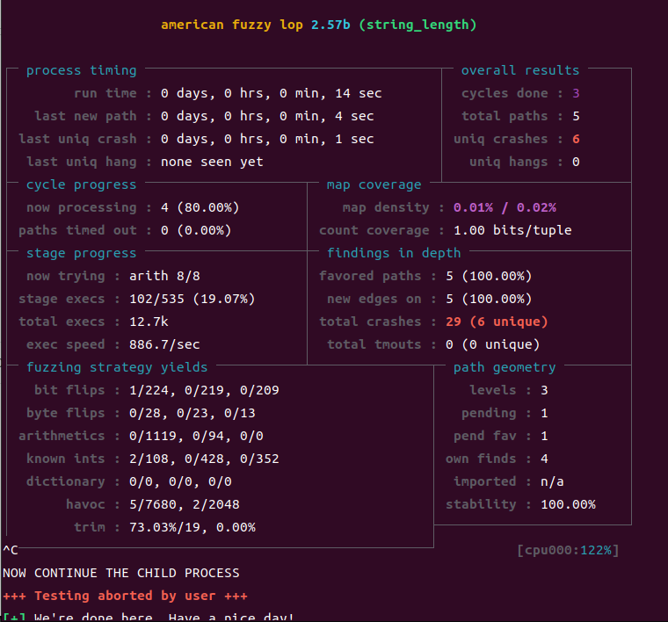

24.5.7

为什么kill(child_pid, SIGSTOP ) 的时候主程序会被停止的问题：原因是child_pid有的时候会为0.

为什么会为0？

因为run_target中通过WIFSTOPPED(status)判断子进程状态，如果子进程正常结束，则把child_pid设置为0。所以是执行到handle_timeout的时候子进程刚好结束。

这样做的原因？

比较一下只在child_pid>0的时候打标记和都打标记的testfile1文件结果

|  |  |
| --- | --- |
| Child_pid>0 | 都打 |
|  |  |

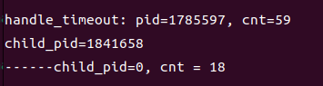

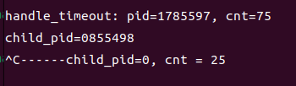

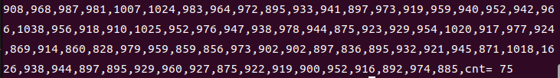





路径多的比路径少的多20%左右条路径